 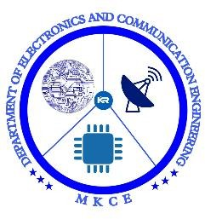

GAS LEAKAGE MONITORING AND ALERTING SYSTEM

# TEAM ID:

PNT2022TMID15909

# TEAM MEMBERS:

1. NAVANEETHA M (927619BEC4129) 2. PAVITHRA S (927619BEC4142)

3. POOVIZHI P (927619BEC4145)

4. SANTHIYA P (927619BEC4174)

# INDUSTRY MENTORS NAME:

1. SOWJANYA
2. SANDEEP DOODIGANI

# FACULTY MENTOR NAME:

**1.** Dr. SIVANANDAM K

# ABSTRACT:

The Internet of things (IoT) is the system of gadgets, vehicles, and home machines that contain hardware ,programming, actuators, and network which enables these things to interface, collaborate and trade information. IoT includes broadening Internet network past standard device, for example, work areas, work stations, cell phones and tablets, to any scope of generally stupid or non-web empowered physical device and ordinary articles. Installed with innovation, these gadgets can convey and connect over the Internet, and they can be remotely observed and controlled . The meaning of the Internet of things has advanced because of union of numerous innovations, ongoing examination, AI, ware sensors, and implanted frameworks. Conventional fields of installed frameworks, remote sensor systems, control frameworks computerization(counting home and building mechanization), and others all add to empowering the Internet of things. A gass pill alludes to a hole of petroleum gas or different vaporous item from a pipeline or other regulation into any territory where the gas ought not be available. Since a little hole may steadily develop a hazardous convergence of gas, spills are perilous. Not with standing causing flame and blast dangers, holes can slaughter vegetation, including huge trees, and may discharge amazing ozone harming substances to the environment. Keywords: IOT, MQ5 sensor, Arduino module, GSM networks.

.

# LITERATURE REVIEW:

We use Internet of Things (IoT) Based Gas Leakage Monitoring and Alerting System with Mq-5 Sensor..Rohan Chandra who published the system in the year of 2018. A discussion on howthe aims and objectives are met is presented. An overall conclusion IOT based toxic gas detector is it has become more efficient, more applicable to today’s applications and smarter. This paper is the choice of using a real time gas leakage monitoring and Sensing the output level..

# AUTHOR: Rohan Chandra Pandey

**DESCRIPTION:** The Internet of Things (IOT) Based Gas Leakage Monitoring and Alerting System with MQ-2 Sensor. This paper choice of using a real time gas leakage monitoring and Sensing the output levels of gas has been clearly observed by the help of this system. The Internet of Things (IoT) is an essential theme in innovation industry, strategy, and designing circles.

# AUTHOR: Asmita Varma, Prabhakar S, Kayalvizhi Jayavel

**DESCRIPTION:** Gas Leakage Detection and Smart Alerting and Prediction Using IoT.Theproposed gas leakage detector is promising in the Field of safety.The meaning of the Internet of things has advanced because of union of numerous innovations, ongoing examination, AI, ware sensors, and implanted frameworks. Conventional fields of installed frameworks, remote sensor systems, control frameworks computerization (counting home and buildingmechanization), and others all add to empowering the Internet of things.

# AUTHOR: : Chaitali Bagwe, Vidya Ghadi, Vinayshri Naik, Neha Kunte

**DESCRIPTION:** IOT Based Gas Leakage Detection System with Database Logging, Prediction and Smart AlertingThe system provides constant monitoring and detectionof gasleakage along with storage of data in database for predictions and analysis. TheIOTcomponents used helps in making the system much more cost effective in comparisonwithtraditional Gas detector systems.

# AUTHOR: Manish Verma, Lumesh Kumar Sahu, Saurabh Deshmukh

**DESCRIPTION:** Internet of Things (IoT) Based Gas Leakage Monitoring and AlertingSystem with Mq-5 SensorA discussion on how the aims and objectives are met is presented. An overall conclusion IOT based toxic gas detector is it has become more efficient, moreapplicable to today’s applications and smarter.IoT is an expanding network of physical devices that are linked with different types of sensors and with the help of connectivitytotheinternet; they are able to exchange data. Through IoT, internet has now extended its rootsto almost every possible thing present around us and is no more limited to our personal computers and mobile phones. Safety, the elementary concern of any project, has not beenleft untouched by IoT. Gas Leakages in open or closed areas can prove to be dangerous andlethal. The traditional Gas Leakage Detector Systems though have great precision, fail toacknowledge a few factors in the field of alerting the people about the leakage. Thereforewehave used the IoT technology to make a Gas Leakage Detector having Smart Alertingtechniques involving calling, sending text message and an e-mail to the concerned authorityand an ability to predict hazardous situation so that people could be made aware in advanceby performing data analytics on sensor readings.

# AUTHOR: Shital Imade, Priyanka Rajmanes, Aishwarya Gavali

**DESCRIPTION:** This model proposes Gas Leakage Detection and Smart AlertingSystemUsing IoT.In this paper we use IOT technology for enhancing the existing safety standards. While making this prototype has been to bring a revolution in the field of safety against theleakage of harmful and toxic gases.

# LM 35 (temp. sensor)

# For the sensors, if any fire is to be happened then the temperature sensor will sense anhigh change(positive change) in temperature and will send an pulse to microcontroller which intern will send an update to the internet through IoT, and as well it will trigger an sirenal arm in the RF Rx kit(sub board).

# MQ-2 (Gas Sensor)

# MQ 2 sensor is basically an LPG (liquefied petroleum gas) which is composed of propane&butane, so when a gas leakage is sensed by the sensor it will send an high pulse totheMcwhich will update it in the IoT, and even[5] an buzzer is heard in the RF Rx kit. Andtheproblem can be sorted & solved.

# AUTHOR: : Petros Spachos , Liang Song and Dimitrios Hatzinakos

**DESCRIPTION:** In this project they prepare a prototype of Wireless Sensor Network(WSN) to monitor and locate gas leaks of a complex indoor environment. Specifically, amobile node is moving inside a building to monitor any leakage of carbon dioxide (CO2), supporting and displaying the level and the location of the leakage. Throughout the demonstration, the technological advantages of cognitive networking along with multichip prouting are explored.

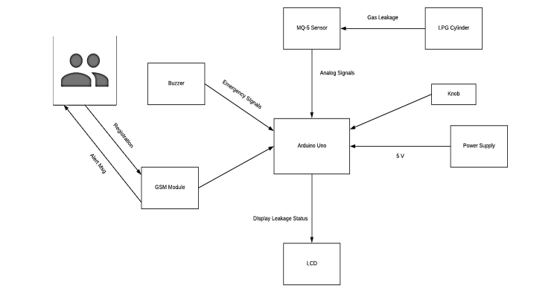

**FIG 1 : System Architecture**

# AUTHOR: Vidya Ghadi, Vinayshri Naik, Neha Kunte

**DESCRIPTION:** The system provides constant monitoring and detection of gas leakage along with storage of data in database for predictions and analysis. The IOT components used helps in making the system much more cost effective in comparison with traditional Gas detector systems. An overall conclusion IOT based toxic gas detector is it has become more efficient, more applicable .